**Project** : IOT Based smart crop protection system for agriculture

## **Project Design Phase-1**: **PROBLEM SOLUTION FIT**

**1) If the environment is seriously harmed by factors such as temperature, PH level, humidity, and light intensity.**

**2) Farmers that are less productive will see a decline in their profits**.

**TEAM ID : PNT2022TMID00315** 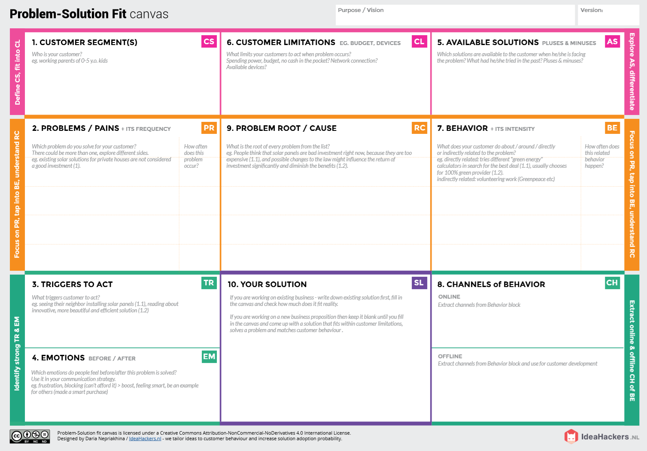

**OFFLINE: Farmers use control measures to keep an eye on their fields.**

**ONLINE: Information on farms sent to farmers via an application.**

**Attempts to discover a solution to stop this issue directly connected**

**Located in a remote area where internet connectivity may not be robust enough to support quick transmission speeds.**

**Tracking several indicators with a smartphone or online application makes farming an agricultural field simple.**

**"Smart crop protection system for agriculture based on IOT"!!**

**By safeguarding crops against pests, diseases, and weeds and increasing output per hectare, it aids farmers in producing more food on less area.**

.

**1) Exorbitant adoption fees and security issues.**

**2) Ignoring the application of IOT in agriculture.**

**•Controlling and observing it is**

**challenging**

**•It is unknown if the application is**

**Defective .**

**The farmer's! who’s isn't close to his field**

**Create possibilities to help individuals in underdeveloped countries escape poverty. (Over 60%)**

**Before: Financial issues, heavy workload, and marital discord.**

**AFTER: It will be simpler to increase field yield.**